CO2 ASSESSMENT -3
Identify and fix the error in the given SQL query that uses incorrect JOIN syntax and returns duplicate results.

Incorrect query
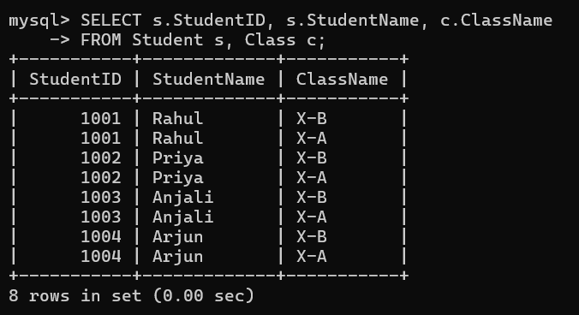

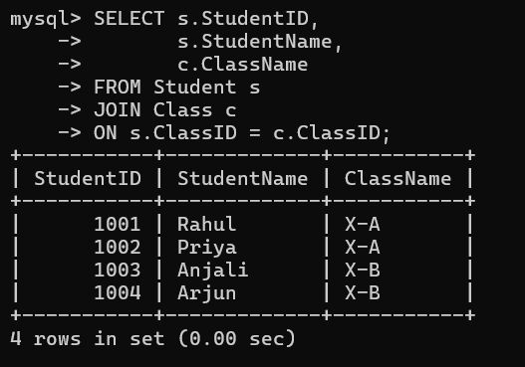
Correct Query

Question 2: The following sub-query returns incorrect results due to a missing correlation. Debug and rewrite it correctly.
Incorrect Query
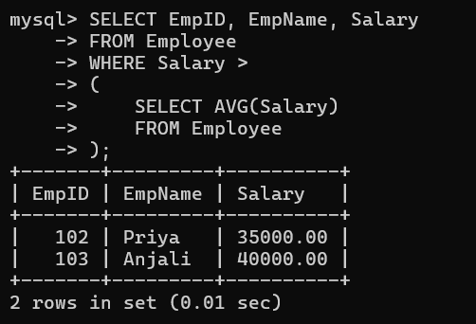

Correct Query
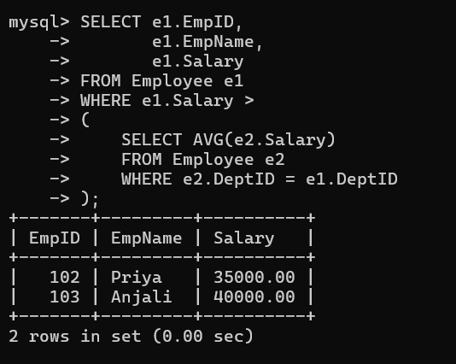

Question 3: The given SQL view definition causes errors when queried. Identify the issue and rewrite a correct and optimized view.
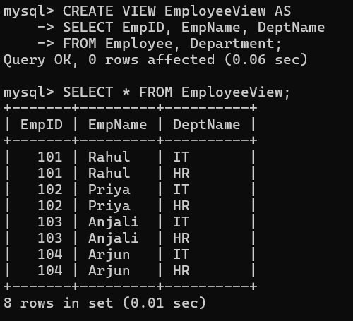
Incorrect Query

Correct Query
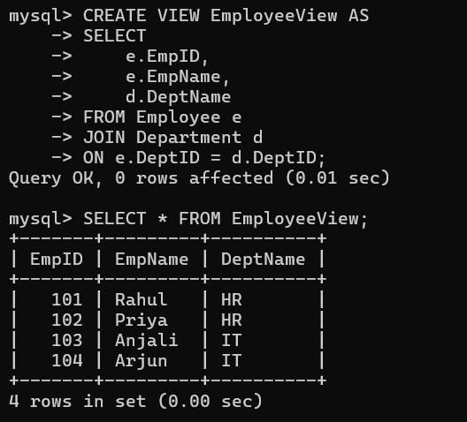

Question 4: Debug the given relational algebra expression that produces incorrect output for a natural join operation.
Incorrect Relational Algebra Expression
Student ⨝ Teacher
Issue
- The Natural Join is performed without a common matching attribute.
- This may produce incorrect or unintended results because the required join condition is missing.
Correct Relational Algebra Expression
Assume:
- Student(StudentID, StudentName, ClassID)
- Class(ClassID, ClassName, TeacherID)
- Teacher(TeacherID, TeacherName)
Step 1: Join Student and Class
Student ⨝ Class
Step 2: Join with Teacher
(Student ⨝ Class) ⨝ Teacher
Final Expression
π StudentID, StudentName, ClassName, TeacherName
((Student ⨝ Class) ⨝ Teacher)
Explanation
- The incorrect expression joins relations that do not share the appropriate common attributes.
- The corrected expression:
  - Joins Student with Class using ClassID.
  - Joins the result with Teacher using TeacherID.
  - Projects only the required attributes.

Question 5: The SQL query below violates referential integrity. Identify the violation and modify the statements to enforce proper constraints.
Incorrect query Statements
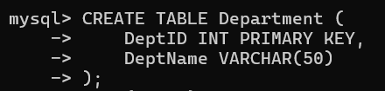

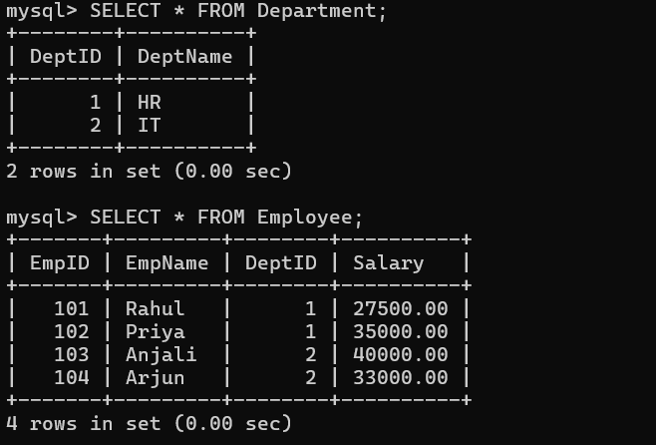
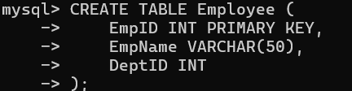
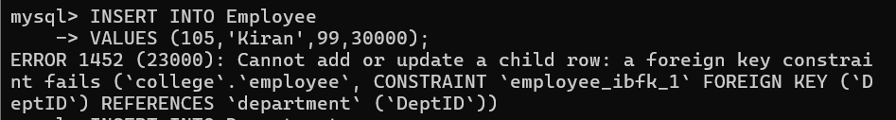

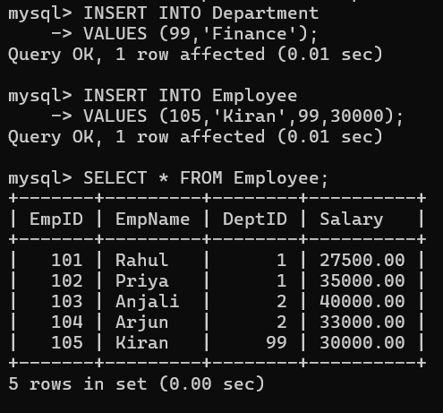
Correct Query

Question 5: The SQL query below violates referential integrity. Identify the violation and modify the statements to enforce proper constraints.
Incorrect Query
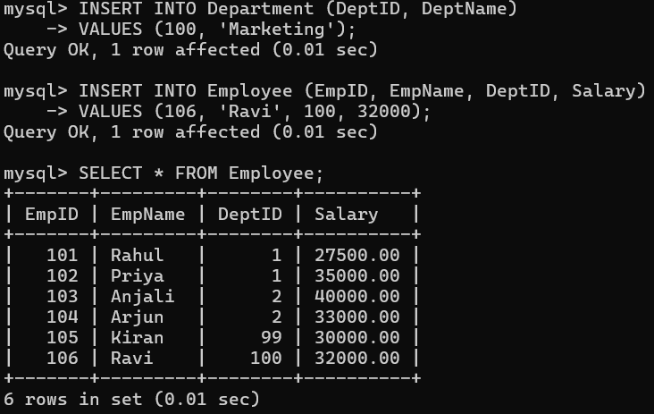
Correct Query
Question 7: Optimize the SQL query by replacing nested sub-queries with JOIN operations and explain the performance improvement.
Incorrect Query
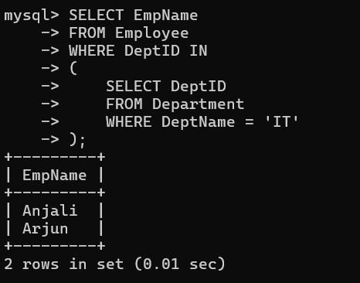

Issue
- Uses a nested subquery.
- On large tables, nested subqueries may be less efficient than JOINs.
- JOINs are generally easier for the database optimizer to execute efficiently.
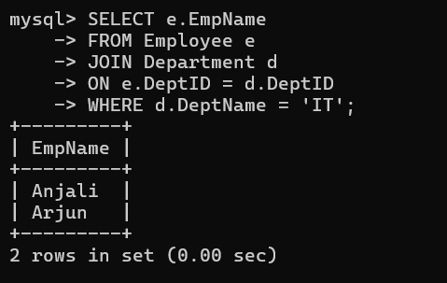
Correct Query

Question 8: Analyze the execution plan of the given SQL query and suggest indexing strategies to improve performance.
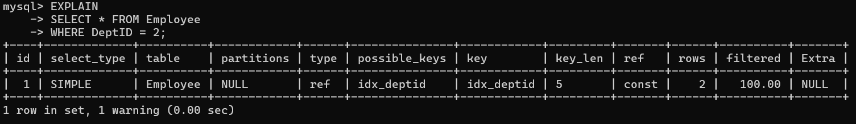
Before Debugging
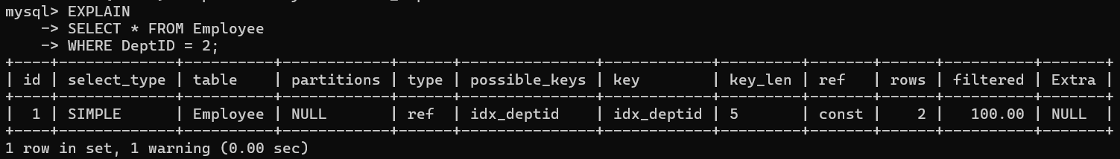
After Debugging
Question 9: Debug the following SQL statements involving transactions and explain how COMMIT and ROLLBACK maintain consistency.
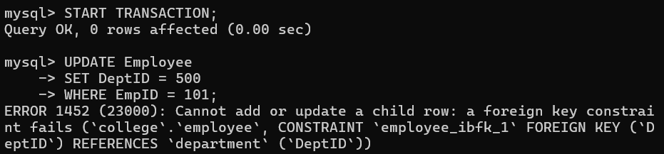
Before Debugging
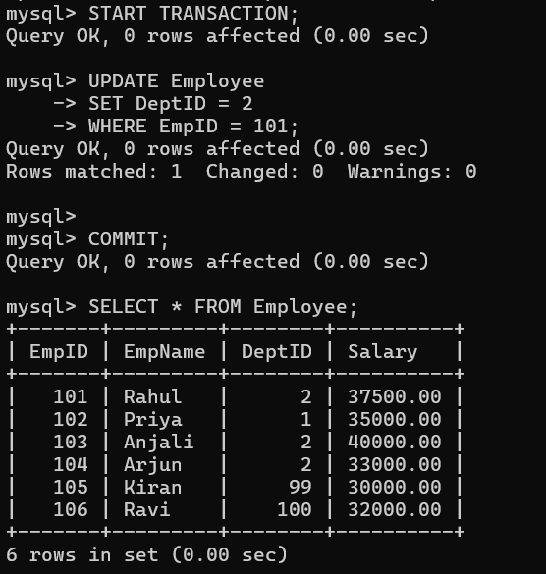
After Debugging

Question 10: Rewrite the inefficient SQL query using best practices and compare the execution time before and after optimization.
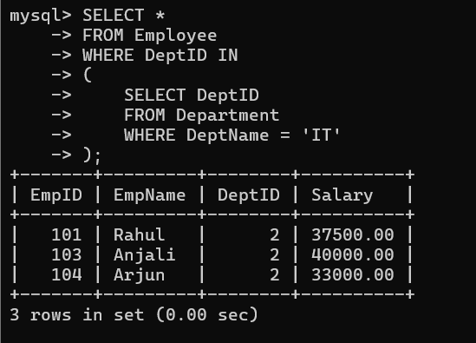
Incorrect Query

Issue
- Uses a nested subquery.
- Less efficient for large tables.
- Harder for the optimizer to process compared to a JOIN.
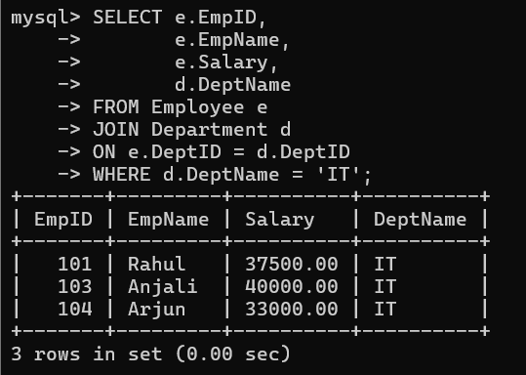
Correct Query

